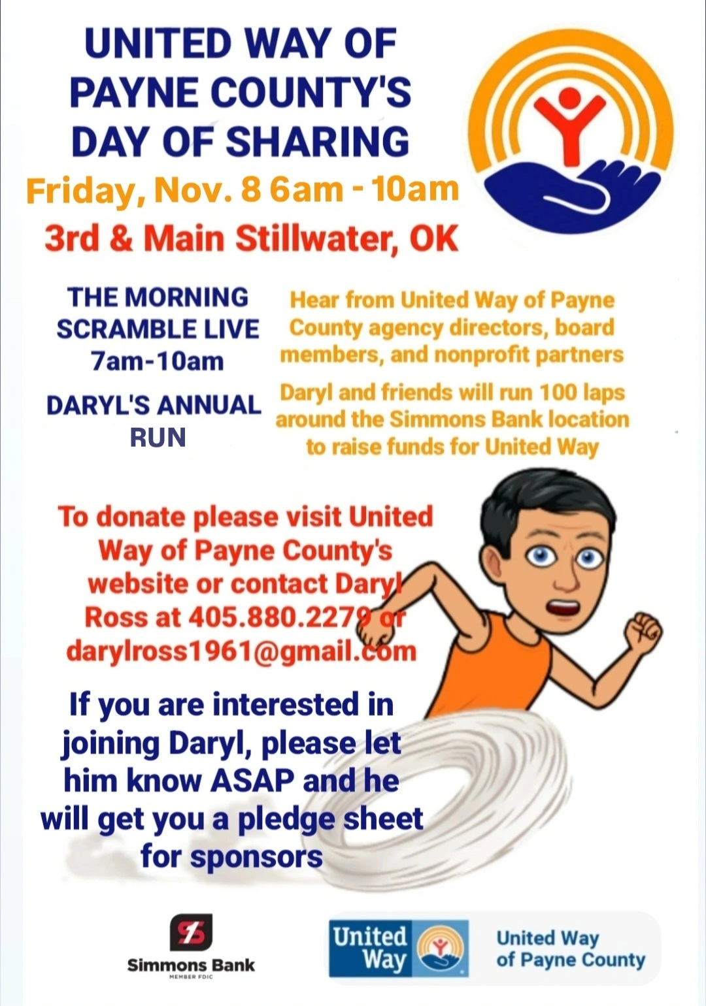

[Click Here](https://acrobat.adobe.com/id/urn:aaid:sc:US:28a8a2e2-5a0a-4eab-84e7-2bd3f1ed0e21) for Run Sponsor Pledge Sheet